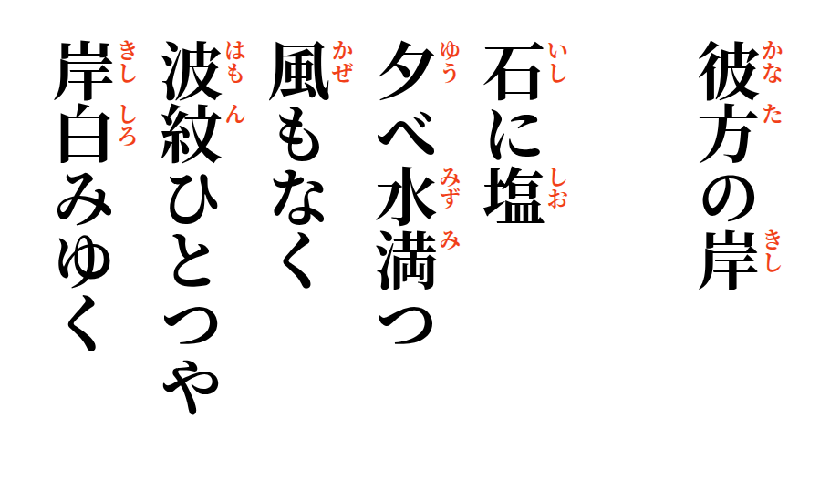

2026-10-03
The Other Shore
Salt upon the stone,
the evening water rising
without wind or rain—
one small ripple reaches
where the far shore turns white.

